

Government of The United Republic of Tanzania

Government of The Republic of Malawi

**The Joint Songwe River Basin Commission**

**Songwe River Basin Development Programme**

**Strengthening Transboundary Cooperation and Integrated Natural Resources Management in the Songwe River Basin (STC&INRM-SRB) Project**

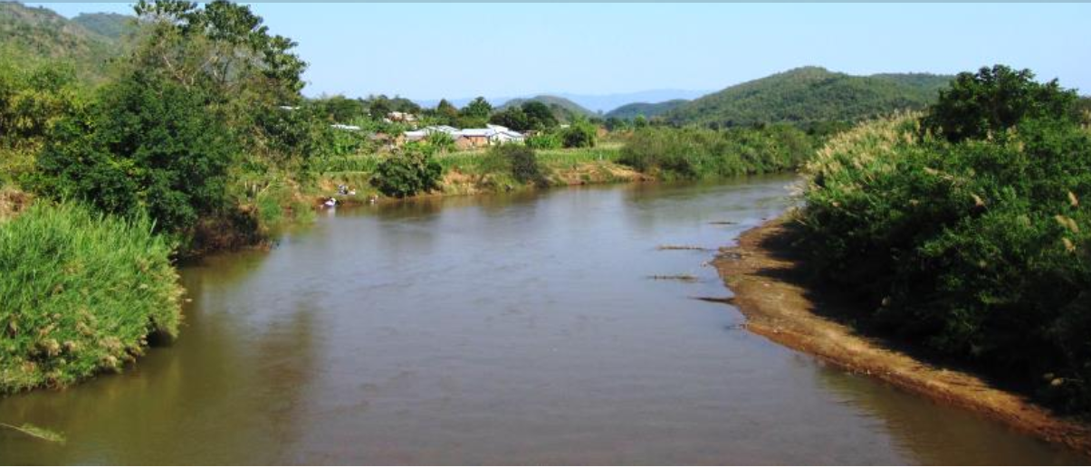

**Stakeholder engagement process**

**key informants interview questionnaire**

**19th – 30th october, 2022**

**PART I: BACKGROUND INFORMATION**

|  |  |
| --- | --- |
| **Name/ID of interviewer** |  |
| **Name of Key Informant** |  |
| **Name of organization** *[if applicable]* |  |
| **Position in the organization** |  |
| **Sex of the Key Informant**  [1= male, 2= female] |  |
| **Age of the Key Informant**  [years] |  |
| **Experience of working in the SRB** [years] |  |
| **Mobile phone of Key Informant** |  |
| **Region name** |  |
| **District name** |  |
| **Date of interview** |  |
| **Start time** | **___ ___ : ___ ___ AM/PM** |
| **End time** | **___ ___ : ___ ___ AM/PM** |

**PART II: ROLES AND MANDATES OF THE KEY INFORMANT STAKEHOLDER**

QN.1 What are you (private, organization) doing in the SRB in supporting sustainable development of the key growth sectors in the SRB?

|  |  |  |  |  |
| --- | --- | --- | --- | --- |
| **SN** | **Growth sectors1** | **What are your major interventions? (in order of importance)** | | |
|  |  | 1st | 2nd | 3rd |
| 1 |  |  |  |  |
| 2 |  |  |  |  |
| 3 |  |  |  |  |
| 4 |  |  |  |  |
| 5 |  |  |  |  |
| 6 |  |  |  |  |
| 7 |  |  |  |  |
|  |  |  |  |  |

1 **Growth sector:** 1= crop agriculture, 2= animal agriculture, 3= fisheries, 4= forestry, 5= energy, 6= services, 7= mining, 8= Others (specify)______________________

**PART II: TRANSBOUNDARY PROBLEMS, IMPACTS AND SOLUTIONS/ACTIONS**

The ‘transboundary’ term as it applies to defining the transboundary problem must be explained to the Key Informant.

***A transboundary problem*** is an environmental problem that is transboundary in scale – originating in, or contributed by, one country and affecting (or impacting) another in the shared water system – the SRB in this case.

**QN2. What are transboundary problems in the SRB, impacted growth sectors and solutions/actions?**

|  |  |  |  |  |
| --- | --- | --- | --- | --- |
| **SN** | **Priority transboundary problem** | **Impacted growth sectors2**  [*multiple response allowed*] | **Impacted activities in the growth sector3** [*multiple response allowed*] | **Major solution/action to address the priority problem** |
| 1 |  |  |  |  |
| 2 |  |  |  |  |
| 3 |  |  |  |  |
| 4 |  |  |  |  |
| 5 |  |  |  |  |
| 6 |  |  |  |  |
| 7 |  |  |  |  |
| 9 |  |  |  |  |

2 **Growth sectors:** 1= crop agriculture, 2= animal agriculture, 3= fisheries, 4= forestry, 5= energy, 6= services, 7= mining, 8= Others (specify)______________________

3 **Impacted activities in the growth sector:** 1= crop production, 2= irrigation, 3= soil health/fertility, 4= grazing/feeding animals, 5= domestic water supply, 6= forestry conservation, 7= biodiversity (habitat, species etc), 8= fishing, 9= marketing/trade, 10= transportation, 11= Others (specify)__________________________

**PART III: STAKEHOLDER IDENTIFICATION**

The Key Informant will identify key stakeholders that matter most in successfully and impactfully undertaking each of the major solutions/actions he/she identified (QN2) that address priority transboundary problems across key growth sectors.

**QN3. Who are the key stakeholders that matter most in successfully and impactfully undertaking the solutions/actions identified in QN2?**

**3(a) Who will contribute to this solution/action?**

|  |  |  |  |  |
| --- | --- | --- | --- | --- |
| **Solution**  **SN-QN2** | **Name of stakeholder (in full)** | **Contact address** | **What will this stakeholder contribute to the solution?** | **Likelihood of contributing to the solution4** |
|  |  |  |  |  |
|  |  |  |  |  |
|  |  |  |  |  |
|  |  |  |  |  |
|  |  |  |  |  |
|  |  |  |  |  |

4 **Likelihood of contributing:** 1= very likely, 2= likely, 3= do not know, 4=unlikely 5= very unlikely

**3(b) Who will be affected by it, and how?**

|  |  |  |  |  |
| --- | --- | --- | --- | --- |
| **Solution**  **SN-QN2** | **Name of stakeholder (in full)** | **Contact address** | **How will this stakeholder be affected by the solution?** | **Likelihood of being affected by the solution5** |
|  |  |  |  |  |
|  |  |  |  |  |
|  |  |  |  |  |
|  |  |  |  |  |
|  |  |  |  |  |
|  |  |  |  |  |

5 **Likelihood of being affected:** 1= very likely, 2= likely, 3= do not know, 4=unlikely 5= very unlikely

**3(c) Who can influence it, directly or indirectly?**

|  |  |  |  |  |
| --- | --- | --- | --- | --- |
| **Solution**  **SN-QN2** | **Name of stakeholder (in full)** | **Contact address** | **How will this stakeholder influence the solution?** | **Likelihood of influencing the solution6** |
|  |  |  |  |  |
|  |  |  |  |  |
|  |  |  |  |  |
|  |  |  |  |  |
|  |  |  |  |  |
|  |  |  |  |  |

6 **Likelihood of influencing:** 1= very likely, 2= likely, 3= do not know, 4=unlikely 5= very unlikely

**PART IV: STAKEHOLDER ANALYSIS**

The stakeholder analysis will basically consider how will the solution/action affect the stakeholder.

**QN4. How does the solution/action affect the stakeholder?**

|  |  |  |  |  |
| --- | --- | --- | --- | --- |
| **Solution**  **SN-QN2** | **Name of stakeholder (in full)** | **Contact address** | **How will the solution/action affect the stakeholder?** | **Likelihood of being affected by the solution7** |
|  |  |  |  |  |
|  |  |  |  |  |
|  |  |  |  |  |
|  |  |  |  |  |
|  |  |  |  |  |
|  |  |  |  |  |

7 **Likelihood of being affected by the solution:** 1= very likely, 2= likely, 3= do not know, 4=unlikely 5= very unlikely

**PART V: STAKEHOLDER MAPPING**

The key informant will be asked to provide information that will help to complete the mapping. Two aspects are critical:

* Importance (relevance) of the solution/action and expected results to the stakeholder. This involves ordinal rating by the key informant – Low or High; and
* Influence of the stakeholder over the solution/action for achieving intended results – hence warranting a particular level of engagement: key informant will state whether to Inform, Consult, Involve, Collaborate or Empower.

**QN5. How important to the stakeholder is the solution/action and how is it influenced by the stakeholder?**

**5(a) How important to the stakeholder is the solution/action’s intended results?**

|  |  |  |  |  |
| --- | --- | --- | --- | --- |
| **Solution**  **SN-QN2** | **Name of stakeholder (in full)** | **Contact address** | **How important is the solution/action’s results to the stakeholder?** | **Level of importance8** |
|  |  |  |  |  |
|  |  |  |  |  |
|  |  |  |  |  |
|  |  |  |  |  |
|  |  |  |  |  |
|  |  |  |  |  |

8 **Level of importance of the solution:** 1= very high, 2= high, 3= do not know, 4=low, 5= very low

**5(b) How much influence the stakeholder has on the solution/action to achieve intended results and nature of engagement?**

|  |  |  |  |  |  |
| --- | --- | --- | --- | --- | --- |
| **Solution**  **SN-QN2** | **Name of stakeholder (in full)** | **Contact address** | **What is the influence the stakeholder has on the solution/action to achieve intended results?** | **The level of influence9** | **Nature of engagement with the stakeholder10** |
|  |  |  |  |  |  |
|  |  |  |  |  |  |
|  |  |  |  |  |  |
|  |  |  |  |  |  |
|  |  |  |  |  |  |
|  |  |  |  |  |  |

9 **The level of influence:** 1= very high, 2= high, 3= do not know, 4=low, 5= very low

10 **Nature of engagement with the stakeholder:** 1= inform, 2= consult, 3= involve, 4=collaborate, 5= empower

**PART VI: STAKEHOLDER ENGAGEMENT PLAN**

The Key Informant will be interviewed to fill the questions in Table that will input into Stakeholders Engagement Plan (SEP). The expert will complete other components of the SEP including resources required to implement the strategy and responsible entities to implement the engagement strategies

**QN6. Could you please answer the following questions related with the engagement plan with stakeholder you have presented?**

|  |  |  |  |  |  |  |  |
| --- | --- | --- | --- | --- | --- | --- | --- |
| **Solution**  **SN-QN2** | **Name of stakeholder (in full)** | **Contact address** | **Nature of engagement11** | **Potential barriers to engagement** | **Potential enablers of engagement** | **Strategy of engagement12** | **Frequency13** |
|  |  |  |  |  |  |  |  |
|  |  |  |  |  |  |  |  |
|  |  |  |  |  |  |  |  |
|  |  |  |  |  |  |  |  |
|  |  |  |  |  |  |  |  |
|  |  |  |  |  |  |  |  |
|  |  |  |  |  |  |  |  |
|  |  |  |  |  |  |  |  |
|  |  |  |  |  |  |  |  |
|  |  |  |  |  |  |  |  |
|  |  |  |  |  |  |  |  |
|  |  |  |  |  |  |  |  |

**11** **Nature of engagement with the stakeholder:** 1= inform, 2= consult, 3= involve, 4=collaborate, 5= empower

**12 Strategy of engagement:** 1= meetings (physical/virtual), 2= phone calls, 3= press events, 4= emails, 5= websites, 6= policy briefs, 7= newspaper/newsletter, 8= other (specify) _______________

**13 Frequency of engagement:** 1= daily, 2= weekly, 3= monthly, 4= quarterly, 5= biannual, 6= annual